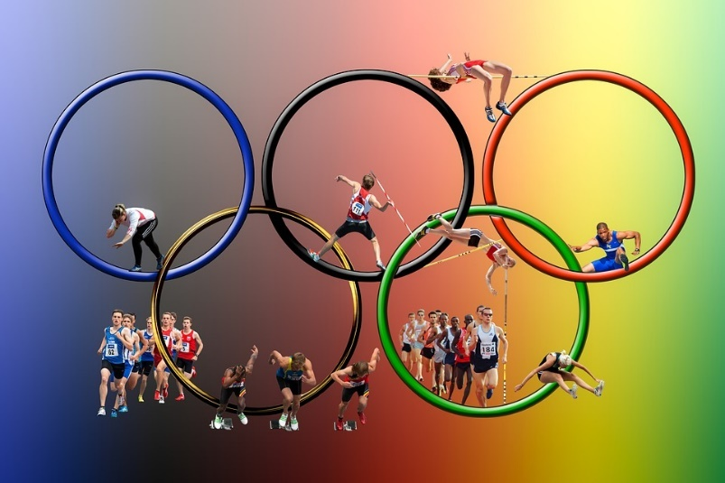
Robot Olympic Games

1. Shuttle race:
- robot runs 30 cm forward
- runs backwards without turning
2. 2x30 m race:
- robot runs 30 cm forward
- turns around
- runs back the same way
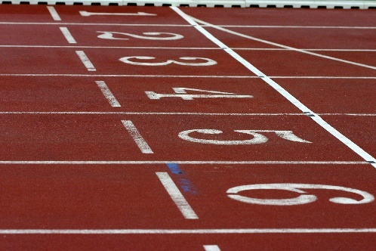
3.Race around cones
- Robot runs till Cone 1 (1)
- Runs around Cone 1 (2-4) and continues forward till Cone 2 (5)
- Runs around Cone 2 (6-7) and runs back to start (8)
6
2
5
4
1
7
3
8

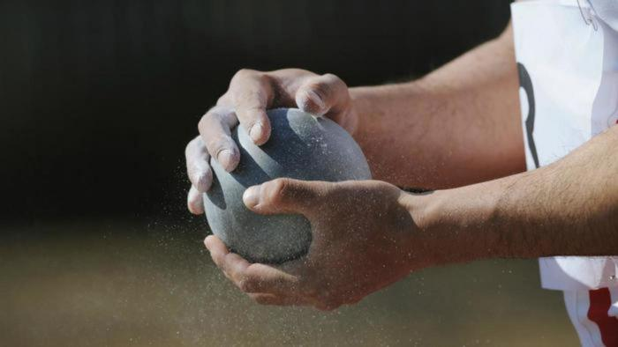
4.Shot put
- Robot turns around itself twice
- Runs quickly 20 cm forward
- Stops
- Waits for 3 seconds
- Turns around and slowly returns to start

